curriculum Design

**The Lionheart Curriculum**

In order for anyone to succeed academically, [nurture needs to be consistent throughout the school environment](https://www.tes.com/magazine/analysis/general/what-whole-school-nurturing-approach-involve) and embedded within the school ethos. Kindness is not weakness but essential in supporting our learners holistically and, in doing so, fostering their resilience.

Students need to feel safe before they can engage with us. We can build their trust through acceptance and empathy with kindness being at the core of all we do. Consistency in our practice and a relentless drive to build positive relationships is vital to finding a way to engage our students. We want to create a student centred approach to the curriculum that is flexible to meet the needs of an ever changing cohort where they are empowered to work towards resilience and independence in their learning.

The curriculum map

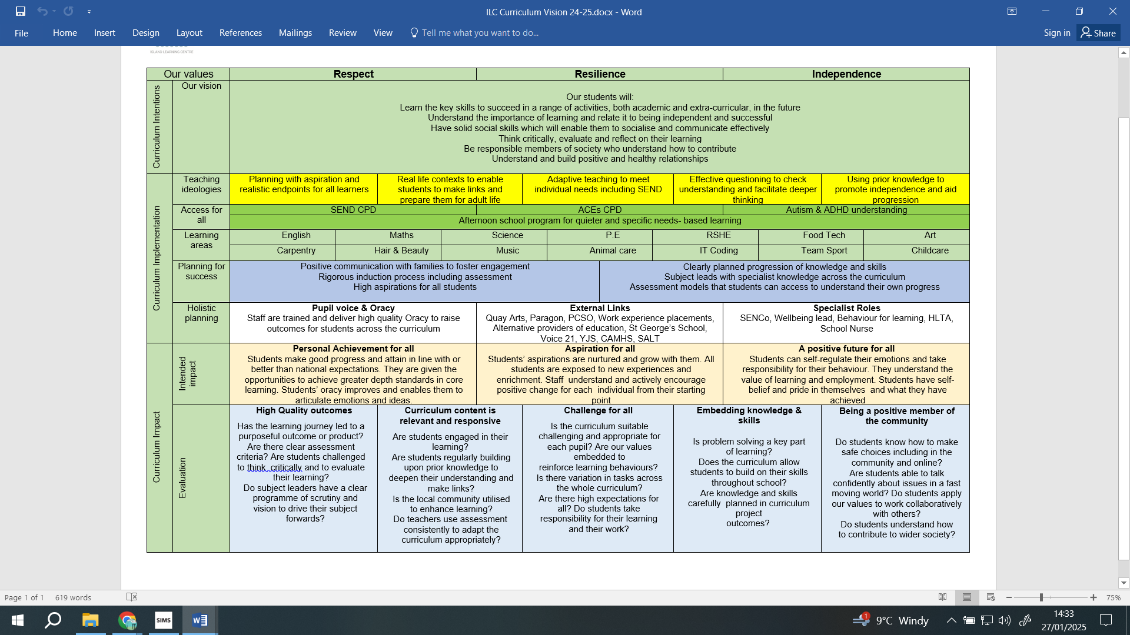

12 week interventions

Some students will be joining us on a 12 week intervention programme. By adopting a skills-first approach with robust assessment and overlapping content, we ensure that students consistently build and retain essential learning skills regardless of their entry or exit point.

For example -

Maths

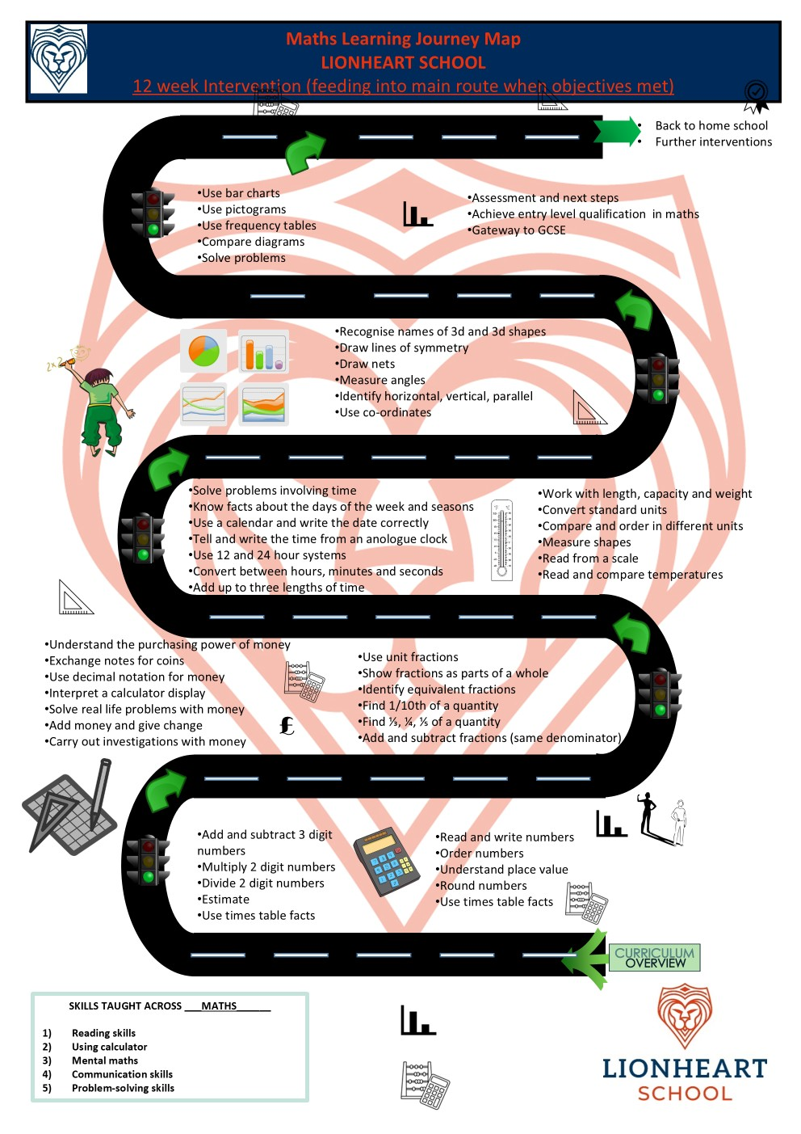

For more able students, once they have demonstrated they are secure with the learning for the week they will swap to the main curriculum road maps.

Curriculum Roadmaps

All subject areas have a curriculum intent document that lays out the purpose of the curriculum for that subject, how this is implemented and the qualification pathways available. Long and medium term plans are in place for all subjects. We are currently working on developing 5 year road maps for each subject to show clearly the path to success but also that links to RSHE, literacy and numeracy.

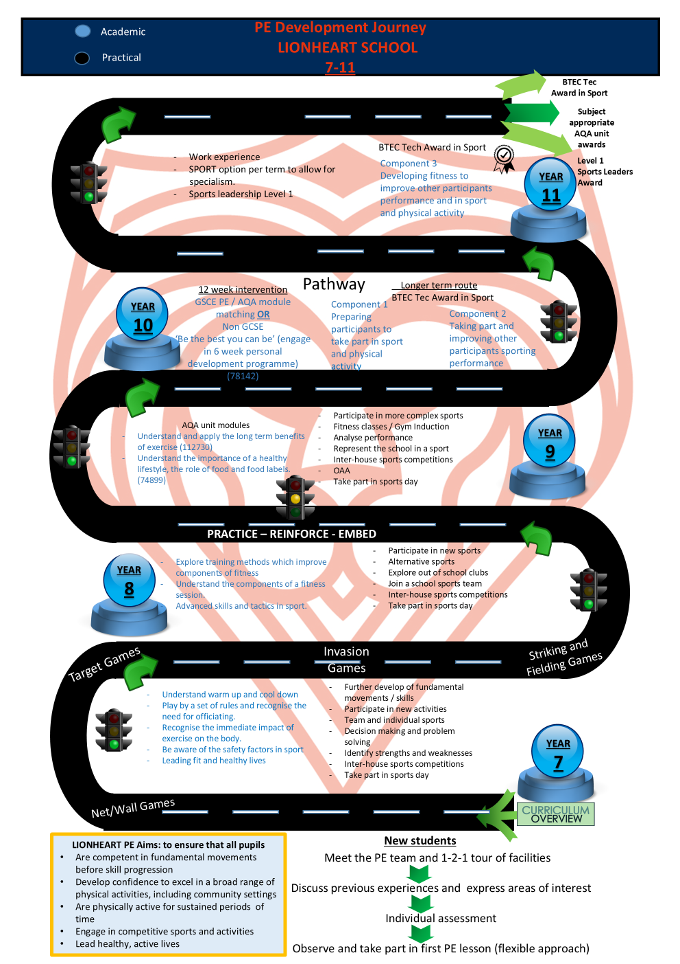

Curriculum overview

|  |  |  |  |  |  |  |  |  |
| --- | --- | --- | --- | --- | --- | --- | --- | --- |
|  | Maths | English | Science | PE | Art | Food | Voc options | RSHE  RE  Careers |
| KS3 | 4 | 5 | 4 | 3 | 2 | 2 | 2 | 2 |
| 10 | 4 | 5 | 4 | 3 | 2 | 2 | 2 | 2 |
| 11 | 5 | 5 | 5 | 1 PE plus 4 lessons option of 2 courses | | | 2 | 2 |

Vocational options include carpentry, hair and beauty, child care, health and social care, geography, English Literature and change according to need and interests of students.

Qualifications

Maths, English and Science all offer Entry level qualifications and GCSE at foundation and higher tier. There is a progression pathway in place.

Food offers Jamie Oliver BTEC in home cooking in year 11 and a range of AQA awards

Art offers a variety of AQA awards, level 2 BTEC or GCSE

PE currently offers AQA awards but we will be offering Level 1 and 2 BTEC

Music offers a range of AQA awards

Bespoke qualifications such as language GCSEs are offered for students with a gift in this are

|  |  |  |  |
| --- | --- | --- | --- |
|  | Our curriculum should: | Why is this important? | How leaders make this happen |
| 1 | Encourage a love of learning and be delivered by staff who are experts in their subject and passionate about the topics they teach. | Students and staff who are well read and passionate about learning and will continue to learn and develop. They will continue to research their own pedagogical practice, modelling that love of learning. | By ensuring time is allocated for departments to work collaboratively. Ensuring experts are appointed into subject areas which |
| 2 | Within individual subjects focus on the depth of learning that is relevant to our community and our students. | Less can often be more. Subject areas have thought carefully about what depth means in their subject and how this can be achieved by choosing topics that are relevant to our cohort. These are mapped on their curriculum roadmaps | Curriculum roadmaps show what is to be taught and the depth of student. These are revised each year, with some subjects implementing emergency curricula in response to ongoing gaps |
| 3 | Prepare our students for GCSE and the wider world BUT not be driven by the demands of GCSE. | Whilst success at GCSE is important, our role is about preparing for post-16. This may be subject specialisms, but this may be a wider knowledge. | Review where students move onto post-16, and ensure that our curriculum allows students access to their course |
| 4 | Be underpinned by knowledge-rich learning that builds with each term and year. | Knowing more and remembering more is the key to success. Our curriculum should be knowledge-rich and staff must have the expectation that core knowledge is remembered. | Knowledge organisers outline what needs to be remembered and skilled retrieval techniques ensure that knowledge is checked regularly. |
| 5 | Be mapped out explicitly so that knowledge is transparent for staff, students and parents. | Our curriculum should be fully mapped out and the curriculum roadmaps and highlighted in each area and on our website so that staff can build knowledge, students know where they are headed and parents can support us. | Curriculum roadmaps displayed in classrooms and on websites with parents informed of what is being taught to enable them to support at home. |
| 6 | Allow for key concepts, themes or areas of knowledge to be revisited but not repeated. | Revisiting key areas is crucial to allow students to build their learning. However, this should not be a case of repeating the same content as this is not challenging our students. | All heads of department are subject experts in their area and build curricula which revise and not redo |
| 7 | Allow for natural links across subjects to be made. | Subjects can support each other with learning, for example, the physics teams by the knowledge in mathematics, the common thread of British values and careers… These links need to be natural and not forced for their success. | Whole school CPD and also through collaborative projects. Time is allocated for this throughout the year. |